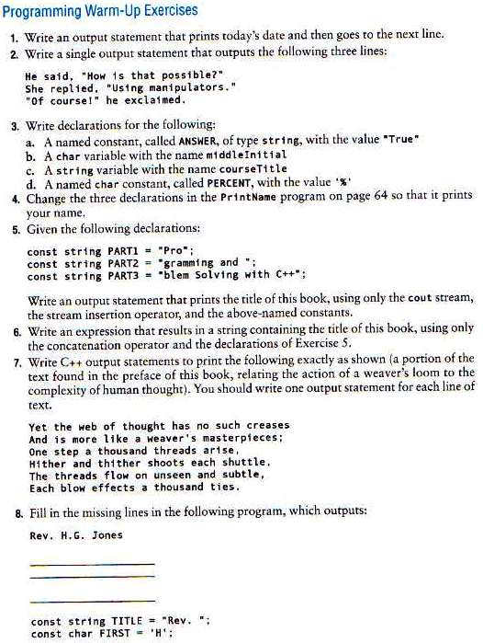  
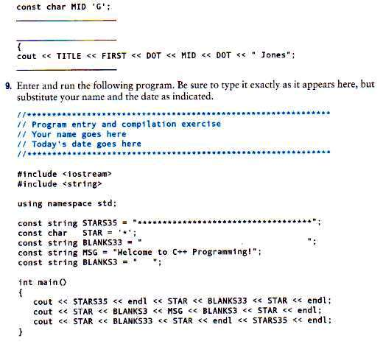

Programming Challenges (Chapter#2 Gaddis text)

1. **Sum of Two Numbers**

Write a program that stores the integers 50 and 100 in variables, and stores the sum of these two in a variable named total.

1. **Sales Prediction**

The East Coast sales division of a company generates 58 percent of total sales. Based on that percentage, write a program that will predict how much the East Coast division will generate if the company has $8.6 million in sales this year.

1. **Sales Tax**

Write a program that will compute the total sales tax on a $95 purchase. Assume the state sales tax is 4 percent, and the county sales tax is 2 percent.

1. **Restaurant Bill**

Write a program that computes the tax and tip on a restaurant bill for a patron with a $88.67 meal charge. The tax should be 6.75 percent of the meal cost. The tip should be 20 percent of the total after adding the tax. Display the meal cost, tax amount, tip amount, and total bill on the screen.

1. **Average of Values**

To get the average of a series of values, you add the values up then divide the sum by the number of values. Write a program that stores the following values in five different variables: 28, 32, 37, 24, and 33. The program should first calculate the sum of these five variables and store the result in a separate variable named sum. Then, the program should divide the sum variable by 5 to get the average. Display the average on the screen. Tip: Use the double data type for all variables in this program.

1. **Annual Pay**

Suppose an employee gets paid every two weeks and earns $2,200 each pay period. In a year, the employee gets paid 26 times. Write a program that defines the following variables:

payAmount - This variable will hold the amount of pay the employee earns each pay period. Initialize the variable with 2200.0.  
payPeriods - This variable will hold the number of pay periods in a year. Initialize the variable with 26.  
annualPay - This variable will hold the employee’s total annual pay, which will be calculated.

The program should calculate the employee’s total annual pay by multiplying the employee’s pay amount by the number of pay periods in a year and store the result in the annualPay variable. Display the total annual pay on the screen.

1. **Ocean Levels**

Assuming the ocean’s level is currently rising at about 1.5 millimeters per year, write a program that displays:

* + The number of millimeters higher than the current level that the ocean’s level will be in 5 years.
  + The number of millimeters higher than the current level that the ocean’s level will be in 7 years.
  + The number of millimeters higher than the current level that the ocean’s level will be in 10 years.

1. **Total Purchase**

A customer in a store is purchasing five items. The prices of the five items are as follows:

Price of item 1 = $15.95

Price of item 2 = $24.95

Price of item 3 = $6.95

Price of item 4 = $12.95

Price of item 5 = $3.95

Write a program that holds the prices of the five items in five variables. Display each item’s price, the subtotal of the sale, the amount of sales tax, and the total. Assume the sales tax is 7 percent.

1. **Cyborg Data Type Sizes**

You have been given a job as a programmer on a Cyborg supercomputer. In order to accomplish some calculations, you need to know how many bytes the following data types use: char, int, float, and double. You do not have any technical documentation, so you can’t look this information up. Write a C++ program that will determine the amount of memory used by these types and display the information on the screen.

1. **Miles per Gallon**

A car holds 15 gallons of gasoline and can travel 375 miles before refueling. Write a program that calculates the number of miles per gallon the car gets. Display the result on the screen.

*Hint:* Use the following formula to calculate miles per gallon (MPG): MPG 5 Miles Driven/Gallons of Gas Used

1. **Distance per Tank of Gas**

A car with a 20-gallon gas tank averages 23.5 miles per gallon when driven in town, and 28.9 miles per gallon when driven on the highway. Write a program that calculates and displays the distance the car can travel on one tank of gas when driven in town and when driven on the highway.

*Hint:* The following formula can be used to calculate the distance: Distance 5 Number of Gallons 3 Average Miles per Gallon

1. **Land Calculation**

One acre of land is equivalent to 43,560 square feet. Write a program that calculates the number of acres in a tract of land with 391,876 square feet.

1. **Circuit Board Price**

An electronics company sells circuit boards at a 35 percent profit. Write a program that will calculate the selling price of a circuit board that costs $14.95. Display the result on the screen.

1. **Personal Information**

Write a program that displays the following pieces of information, each on a separate line:

Your name

Your address, with city, state, and ZIP code

Your telephone number

Your college major

Use only a single cout statement to display all of this information.

1. **Triangle Pattern**

Write a program that displays the following pattern on the screen:

*

***

*****

*******